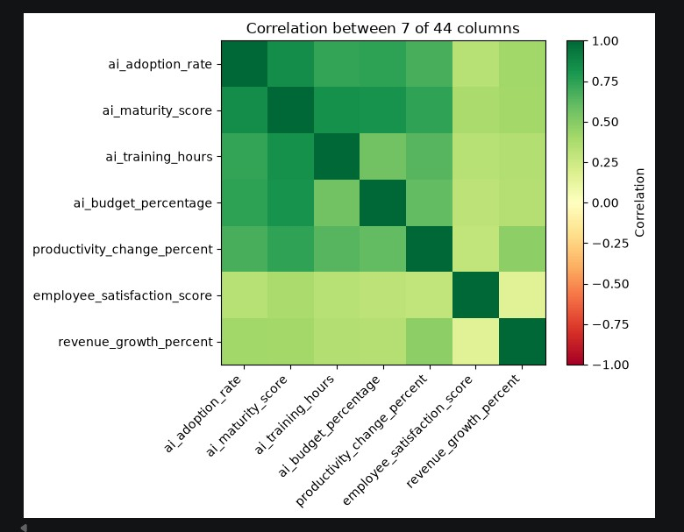

Correlation heatmap — ai_maturity_score is the standout: it moves almost in lockstep with ai_adoption_rate (0.84), and closely with ai_training_hours (0.82) and ai_budget_percentage (0.82). Read that as: how much a company invests in training/budget is tightly bound up with how mature its AI use becomes. employee_satisfaction_score is the odd one out — it barely correlates with anything (0.16–0.38), meaning staff satisfaction isn't really moving with AI investment one way or the other in this dataset.

